**Module 7: Lab Activity – Creating and Using Python Functions**

**Joel Navarrete**

**CSS 225**

**Deliverables:**

Python programs for the following problems. Use the names listed below:

* Problem1AreaOfCircle.py
* Problem2CheckRange.py
* Problem3MulitplyList.py
* Problem4Unique.py
* Problem5Squares.py
* Problem6Flower.py

**All submitted code must include comments:**

# Your Name

# The Date

# The Problem Number and Description

# Any other information throughout your code that is helpful

Python functions are a named sequence of statements that belong together.

All defined functions use the same setup. They consist of compound statements that include a header line and a body as shown below.

def functionName(parameter1, parameter2, etc)

# All statements that are part of this function are

# included here with indention

print(parameter1 + parameter2) # Sample statement

All defined functions must first be defined. To use them, they must be called, passing any needed parameters.

functionName(10, 20) # Sample function call using above example

**Problem 1:** Write a function areaOfCircle(r) which returns the area of a circle of radius r. Make sure you use the math module in your solution.

*#author: Joel Navarrete  
#This program returns the area of a circle when executed*import math  
  
def areaOfCircle(r):  
  
 return math.pi * r**2  
  
  
def main():  
  
 *#print(areaOfCircle(10)* r = float(input(**"Input the radius of the circle : "**))  
 print (**"The area of the cirlce with raidus "** +str(r) + **" is: "**str(areaOfCircle(r)))**"**if __name__ == **"__main__"**:  
 main()

**Problem 2:** Write a Python function to check whether a number is in a given range. Use range(1,10). Print whether the number is in or not in the range.

*#author: Joel Navarrete  
#This program test a number to see if its within range if not the program will tell you*def test_range(n):  
 if n in range(1,10):  
 print(**"Number in range"**)  
 else:  
 print (**"Number not in range"**)  
  
def main():  
  
 number = int(input(**"PLease enter a number to see if it is in range: "**))  
 test_range(number)  
  
if __name__ == **"__main__"**:  
 main()

**Problem 3:** Write a Python function to multiply all the numbers in a list. Use list [5, 2, 7, -1].

*#author: Joel Navarrete  
#program multiplies numbers in the list by the next one giving you the end result of the multiplications*def multiply_list(list):  
  
 result = 1  
  
 for i in list:  
 result = result * i  
  
 return result  
  
def main():  
 *# 0 1 2 3* list = [5, 2, 7, -1]  
  
 print(**"This is the result: "**, multiply_list(list))  
  
if __name__ == **"__main__"**:  
 main()

**Problem 4:** Write a Python function that takes a list of numbers and returns a new list with unique elements of the first list. Use list [1, 3, 3, 3, 6, 2, 3, 5]. Use the append function.

*#author: Joel Navarrete*def unique_list(list):  
 new_list = []  
 for i in list:  
 if i not in new_list:  
 new_list.append(i)  
 return new_list  
  
def main():  
 *# 0 1 2 3* list = [1, 3, 3, 3, 6, 2, 3, 5]  
  
 print(**"Unique list is: "**, unique_list(list))  
  
if __name__ == **"__main__"**:  
 main()

**Problem 5:** Use the following chunk of code as a base to produce the image shown below.

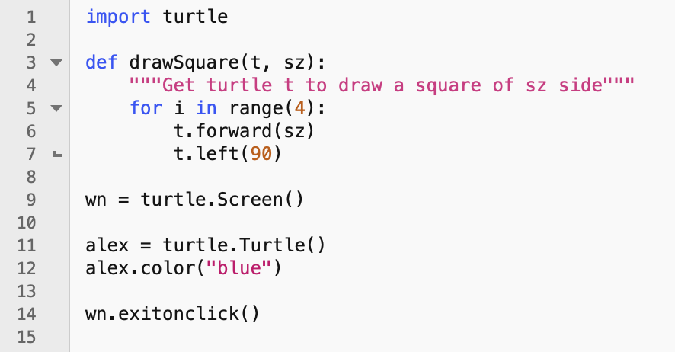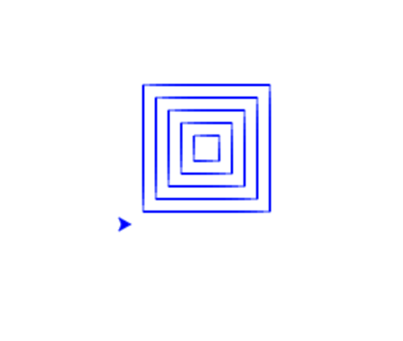

*#author: Joel Navarrete  
#This program will draw a turtle 5 times bigger than the last figure without overlapping*import turtle  
  
def drawSquare(t, sz):  
 for i in range(4):  
 t.forward(sz)  
 t.left(90)  
  
def main():  
 wn = turtle.Screen()  
  
 alex = turtle.Turtle()  
 alex.color(**"blue"**)  
 num = 20  
 for x in range(10):  
 drawSquare(alex, num)  
 alex.penup()  
 alex.backward(10)  
 alex.right(90)  
 alex.forward(10)  
 alex.left(90)  
 alex.pendown()  
 num += 20  
  
 *#drawSquare(alex, 40)  
 #alex.penup()  
 #alex.backward(10)  
 #alex.right(90)  
 #alex.forward(10)  
 #alex.left(90)  
 #alex.pendown()  
 #drawSquare(alex, 60)* wn.exitonclick()  
  
  
if __name__ == **"__main__"**:  
 main()

**Problem 6:** Use the polygon program from the last module and convert it to a function. Call the function in a way to create a pattern similar to below.



*#author: Joel Navarrete  
#This program will draw a figure by going 360 degrees overlapping one another*import turtle  
  
def drawPolygon(t, sz):  
 for i in range(6):  
 t.forward(sz)  
 t.left(60)  
  
def main():  
 wn = turtle.Screen()  
  
 alex = turtle.Turtle()  
 alex.color(**"pink"**)  
 num = 50  
 for x in range(10):  
 drawPolygon(alex, num)  
 alex.right(36)  
  
 wn.exitonclick()  
  
if __name__ == **"__main__"**:  
 main()